**Data Modeling**

1. **Conceptual data model**

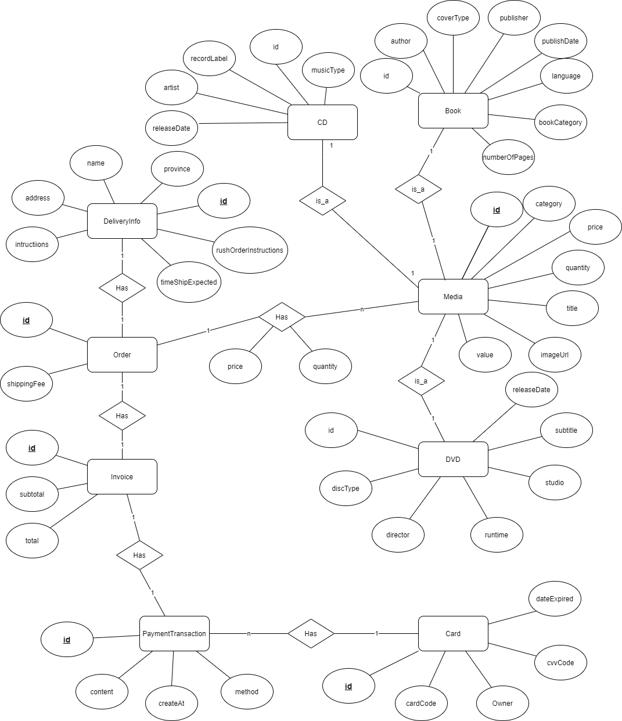

1. **Logical data model**

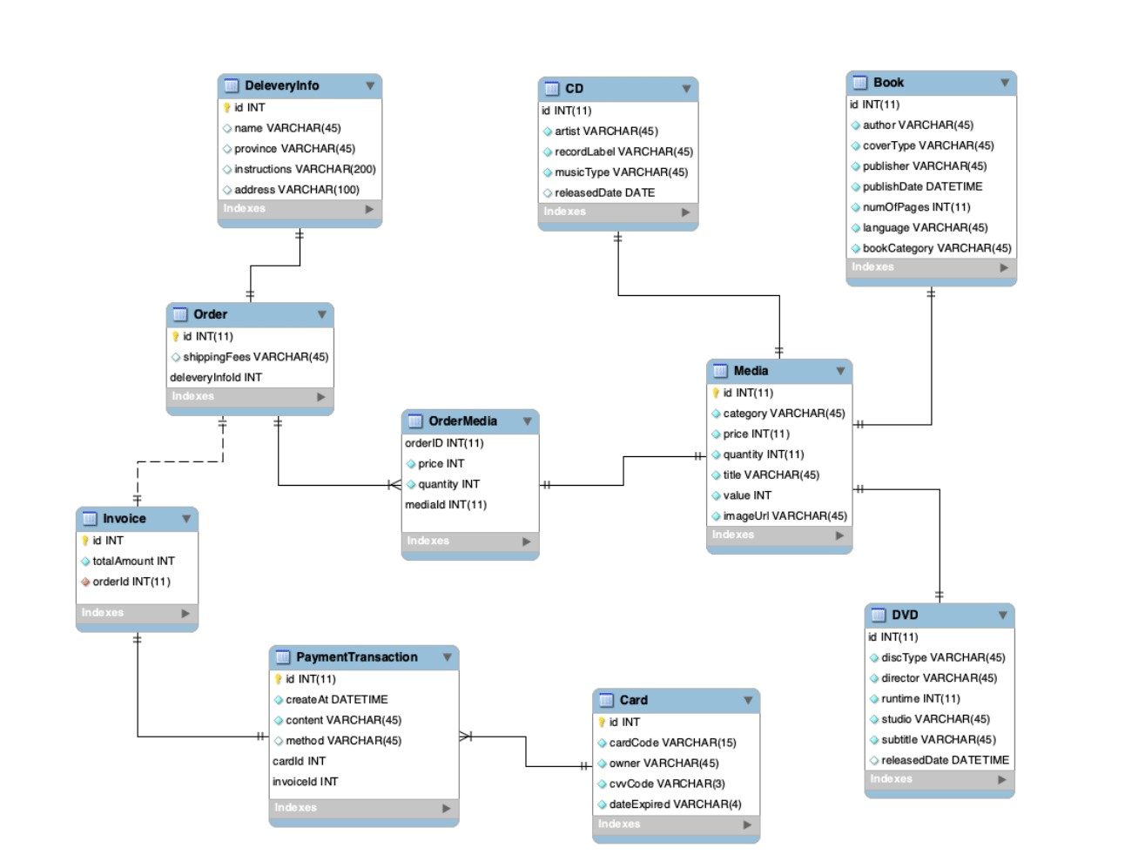

1. **Physical data model**

* **Media**

|  |  |  |  |  |  |  |
| --- | --- | --- | --- | --- | --- | --- |
| # | PK | FK | Column Name | Data Type | Mandatory | Description |
| 1. | x |  | id | Integer | Yes | ID, auto increment |
| 2. |  |  | category | VARCHAR(45) | Yes | Media type: CD, DVD, Book, … |
| 3. |  |  | Price | Integer | Yes | Current price |
| 4. |  |  | Quantity | Integer | Yes | Number of products |
| 5. |  |  | Title | VARCHAR(45) | Yes | Product name |
| 6. |  |  | Value | Integer | Yes | Value of the product |
| 7. |  |  | imageUrl | VARCHAR(45) | Yes | Product image path |

* **CD**

|  |  |  |  |  |  |  |
| --- | --- | --- | --- | --- | --- | --- |
| # | PK | FK | Column Name | Data Type | Mandatory | Description |
| 1. |  | x | id | Integer | Yes | ID, same as ID of Media of which type is CD |
| 2. |  |  | artist | VARCHAR(45) | Yes | Record label |
| 3. |  |  | recordLabel | VARCHAR(45) | Yes | Current price |
| 4. |  |  | musicType | VARCHAR(45) | Yes | Music genres |
| 5. |  |  | releaseDate | Date | Yes | Release date |

* **Book**

|  |  |  |  |  |  |  |
| --- | --- | --- | --- | --- | --- | --- |
| # | PK | FK | Column Name | Data Type | Mandatory | Description |
| 1. |  | x | id | Integer | Yes | ID, same as ID of Media of which type is Book |
| 2. |  |  | author | VARCHAR(45) | Yes | Author |
| 3. |  |  | coverType | VARCHAR(45) | Yes | Cover type |
| 4. |  |  | Publisher | VARCHAR(45) | Yes | Publishing house |
| 5. |  |  | PublishDate | DATETIMME | Yes | Date of publishing |
| 6. |  |  | numberOfPages | Integer | Yes | Page number |
| 7. |  |  | language | VARCHAR(45) | Yes | Language |
| 8. |  |  | bookCategory | VARCHAR(45) | Yes | Book category |

* **DVD**

|  |  |  |  |  |  |  |
| --- | --- | --- | --- | --- | --- | --- |
| # | PK | FK | Column Name | Data Type | Mandatory | Description |
| 1. |  | x | id | Integer | Yes | ID, same as ID of Media of which type is DVD |
| 2. |  |  | discType | VARCHAR(45) | Yes | Media type: CD, DVD, Book, … |
| 3. |  |  | Director | VARCHAR(45) | Yes | Director |
| 4. |  |  | Runtime | Integer | Yes | Duration |
| 5. |  |  | Studio | VARCHAR(45) | Yes | Manufacturer |
| 6. |  |  | Subtitle | VARCHAR(45) | Yes | Subtitles |
| 7. |  |  | releaseDate | DATETIME | Yes | Release date |
| 8. |  |  | filmType | VARCHAR(45) | Yes | Genres |

* **Card**

|  |  |  |  |  |  |  |
| --- | --- | --- | --- | --- | --- | --- |
| # | PK | FK | Column Name | Data Type | Mandatory | Description |
| 1. | x |  | id | Integer | Yes | ID, auto increment |
| 2. |  |  | cardCode | VARCHAR(45) | Yes | Card code |
| 3. |  |  | Owner | VARCHAR(45) | Yes | Card holders |
| 4. |  |  | cvvCode | VARCHAR(45) | Yes | CVV code |
| 5. |  |  | dateExpired | VARCHAR(4) | Expiration date | Value of the product |

* **DeliveryInfo**

|  |  |  |  |  |  |  |
| --- | --- | --- | --- | --- | --- | --- |
| # | PK | FK | Column Name | Data Type | Mandatory | Description |
| 1. | x |  | id | Integer | Yes | ID, auto increment |
| 2. |  |  | Name | VARCHAR(45) | Yes | Receiver name |
| 3. |  |  | Province | VARCHAR(45 | Yes | Provinces |
| 4. |  |  | Instructions | VARCHAR(45) | Yes | Delivery info |
| 5. |  |  | address | VARCHAR(45) | Yes | Delivery address |
| 6. |  |  | rushOrderIntructions | VARCHAR(45) | No | Rush order instructions |
| 7. |  |  | timeShipExpected | DATETIME | No |  |

* **Order**

|  |  |  |  |  |  |  |
| --- | --- | --- | --- | --- | --- | --- |
| # | PK | FK | Column Name | Data Type | Mandatory | Description |
| 1. | x |  | id | Integer | Yes | ID |
| 2. |  |  | ShippingFee | VARCHAR(45) | Yes | Shipping fee |
| 3. |  | x | deliveryInfoId | Integer | Yes | Delivery info |

* **OrderMedia**

|  |  |  |  |  |  |  |
| --- | --- | --- | --- | --- | --- | --- |
| # | PK | FK | Column Name | Data Type | Mandatory | Description |
| 1. |  | X | mediaID | Integer | Yes | Media ID |
| 2. |  | x | prderID | Integer | Yes | Order ID |
| 3. |  |  | Price | Integer | Yes | Selling price |
| 4. |  |  | Quantity | Integer | Yes | Number of products |

* **Invoice**

|  |  |  |  |  |  |  |
| --- | --- | --- | --- | --- | --- | --- |
| # | PK | FK | Column Name | Data Type | Mandatory | Description |
| 1. | x |  | id | Integer | Yes | ID |
| 2. |  |  | subtotal | Integer | Yes | Sub total |
|  |  |  | total | Integer | Yes | Toal |
| 3. |  | x | orderID | Integer | Yes | Order ID |

* **PaymentTransaction**

|  |  |  |  |  |  |  |
| --- | --- | --- | --- | --- | --- | --- |
| # | PK | FK | Column Name | Data Type | Mandatory | Description |
| 1. | x |  | id | Integer | Yes | ID |
| 2. |  |  | createAt | DATETIME | Yes | Transaction contents |
| 3. |  |  | Content | VARCHAR(45) | Yes | Payment methods |
| 4. |  |  | Method | VARCHAR(45) | Yes | Number of products |
| 5. |  |  | cardID | Integer | Yes | ID of user card |
| 6. |  |  | invoiceID | Integer | Yes | Invoice ID |